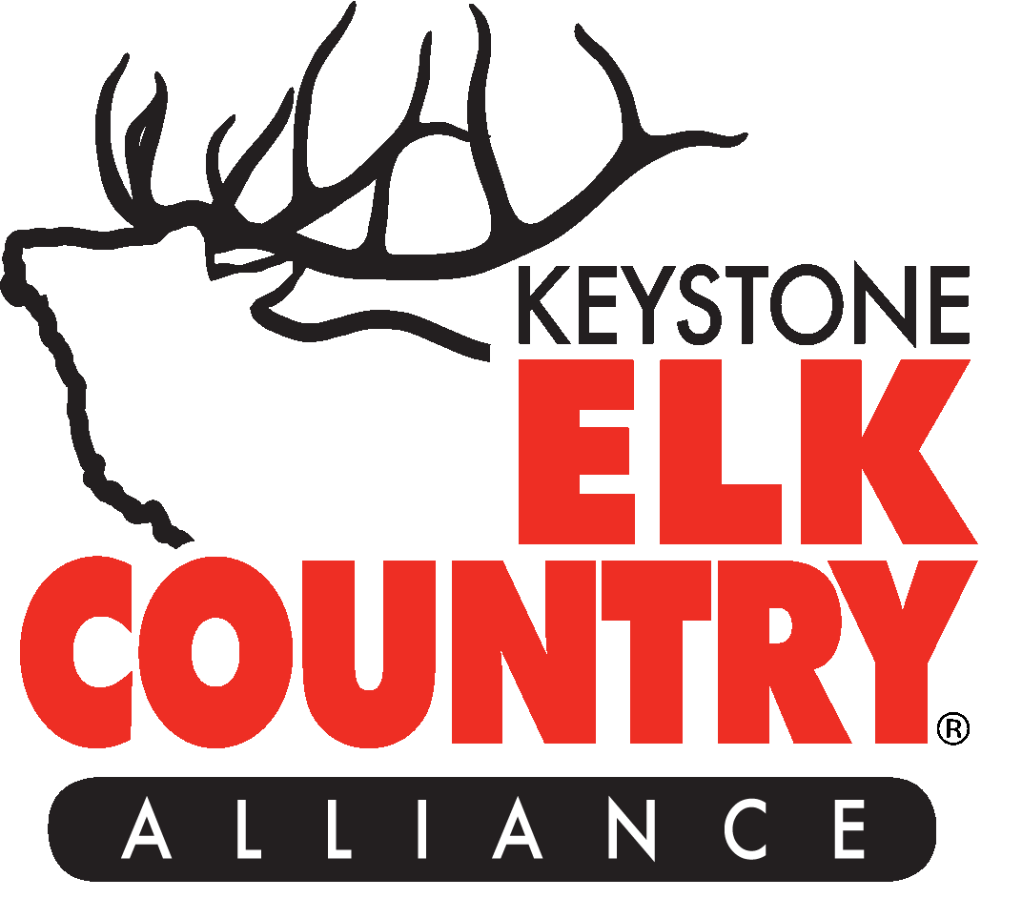 ***Jon DeBerti Memorial Internship***

***“In remembrance of an exceptional Pennsylvania Game Commission Elk Biologist who made a lasting impact on the lives of many.”***

The Keystone Elk Country Alliance is a 501 c(3) nonprofit wildlife conservation organization. We operate, manage and staff the Elk Country Visitor Center in Benezette, PA. KECA’s mission is, *“To conserve and enhance Pennsylvania’s elk country for future generations.”* We accomplish this through conservation education, habitat enhancement and permanent land protection.

**Internship Outline**

**Expectations/Requirements/Qualifications**

-Hard working and motivated

-Professional communication skills

-Positive attitude and eager to learn

-Works well with others

-Current full-time enrollment in a bachelor’s degree, associate/2-year tech program or advanced degree in an acceptable major (wildlife science, conservation education, forestry, natural resource management, environmental science, etc.)

-Freshman year completed or to be complete by May 2024

-Good academic standing (2.5 GPA or higher)

- Valid PA driver’s license

-Background check and clearances

**Experiences/Skills Gained**

-Gain experience in the operations of a nonprofit conservation organization

-Opportunities to provide educational wildlife and conservation programs at the Elk Country Visitor Center

-Acquire skills needed to interact with visitors in a positive manner and provide them with a safe and informative experience in elk country

-Gain hands on experience in habitat management while working with KECA’s habitat crew in improving elk habitat within PA’s elk range

-Help plan and participate in fundraising events at the Elk Country Visitor Center

-Learn valuable information about PA’s elk herd and other natural resources within our state

-Assist with sales and stocking of merchandise in our “Elk Country Store” (gift shop)

-Support our marketing and communications with advertising and social media

**Schedule/Hours/Wage/Location**

-Anticipated starting date: May 2025

-Anticipated ending date: August 2025

-$17.00/hour for 40 hours/week

-Wednesday – Sunday, 9:00 a.m. – 5:00 p.m. (subject to change based on programs and events)

-Elk Country Visitor Center, 134 Homestead Drive, Benezette, PA 15821

**How To Apply**

Email cover letter, resume and transcript showing current enrollment to:

Ben Porkolab

Conservation Education Coordinator

Keystone Elk Country Alliance

814-787-5173

[ConEd@KECAUS.com](mailto:ConEd@KECAUS.com)

**Deadline to apply- February 17, 2025**