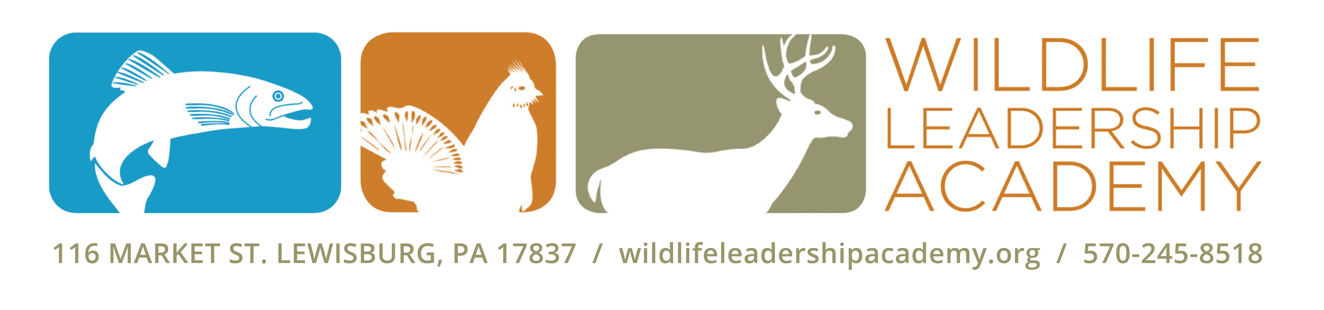

[DATE]

Mr. Smith
Mr. Smith
Smith’s Feed Store
111 Stone Rd.
Forestville, PA 11111

Dear [Mr. Smith],

I am a youth in the [Forestville] community and a student of the Wildlife Leadership
Academy, a 501(c)(3) non-profit, whose mission is to engage and empower high school age youth to become Conservation Ambassadors to ensure a sustained wildlife, fisheries, and natural resource legacy for future generations. This summer, I attended the Pennsylvania [FIELD SCHOOL NAME] Field School where I learned from experts about [SPECIES] and their habitat. My favorite experience at the Field School was [INSERT YOUR STORY HERE.]

At the Academy, we were also taught skills that help us to become leaders in our community. Since the [FIELD SCHOOL NAME]] Field School, I have [SHARE ONE OR A FEW OF YOUR OUTREACH EXPERIENCES]. My outreach has added to the work of many of the students giving back since 2007 when the program first started. Since then, we have engaged with over 30,000 Pennsylvania citizens through education, service, media engagement and the creative arts.

I am taking part in a mission for my class of students to raise $10,000 to Pay It Forward to the next class of Academy students. I want to help pay it forward to the next Academy class because [share a reason you want to help]. My goal is to raise [$XXX]. These funds help to run the program year round and keep the tuition for the Academy low, so students from all income levels can apply. I have enclosed a Donation Form with this letter. Will [Smith’s Feed Store] support my commitment and help me reach my personal fundraising goal?

Your donation is tax deductible and your investment will make a difference by supporting the next generation of conservation leaders. If you want to learn more about the Academy you can visit their website at wildlifeleadershipacademy.org.

I will re-connect with you in the next week to see if you are interested in supporting my mission to pay it forward, or visit my online giving page at wildlifeleadershipacademy.org/janebuck, where you can donate today.

Thank you very much for your time and consideration.

Sincerely,

Jane Buck
Conservation Ambassador, [FIELD SCHOOL], Class of [YEAR]

