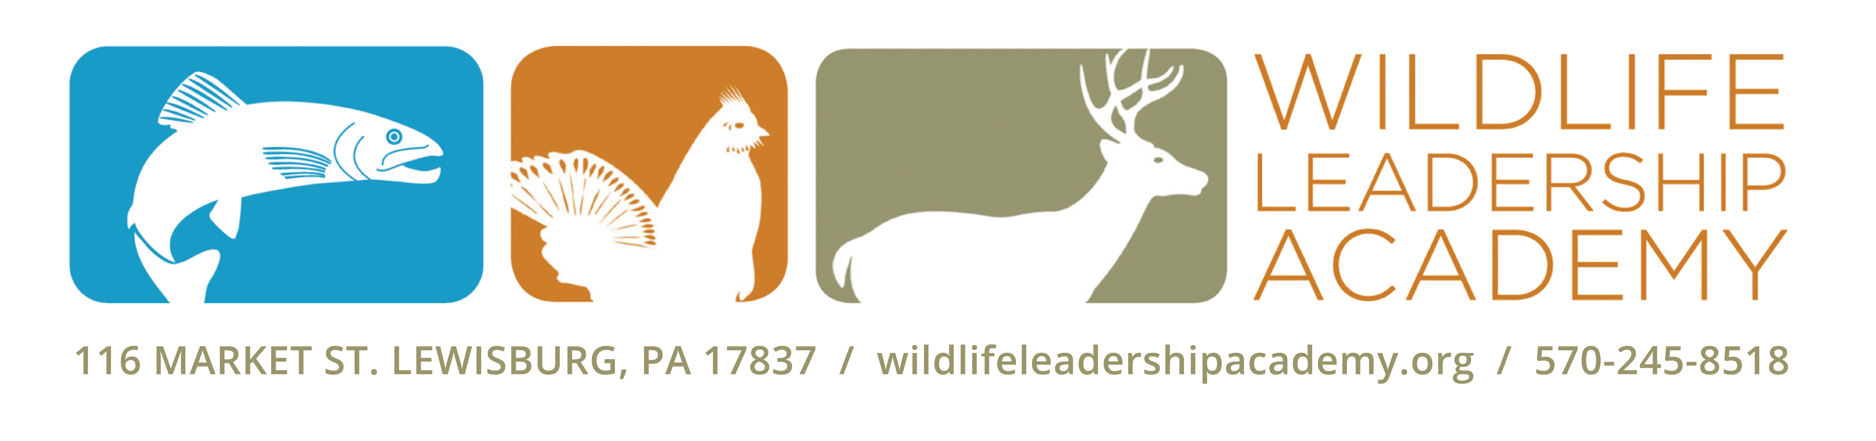

[DATE]

Mr. Smith
Ms. Doe
111 Deer Haven Dr.
Forestville, PA 11111

Dear [Ms. Doe],

I am a student of the Wildlife Leadership Academy, a 501(c)(3) non-profit, whose mission is to engage and empower high school age youth to become Conservation Ambassadors to ensure a sustained wildlife, fisheries, and natural resource legacy for future generations. This past summer, I attended the Pennsylvania [FIELD SCHOOL NAME] Field School where I learned about [SPECIES] and their habitat. My favorite experience at the Field School was [INSERT YOUR STORY HERE].

At the Academy, we were also taught skills that help us to become leaders in our community. Since the [FIELD SCHOOL NAME] Field School, I have [SHARE ONE OR A FEW OF YOUR OUTREACH EXPERIENCES]. My outreach has added to the work of many of the students giving back since 2007 when the program first started. Since then, we have engaged with over 30,000 Pennsylvania citizens through education, service, media engagement and the creative arts.

I am taking part in a mission for my class of students to raise $10,000 to Pay It Forward to the next class of Academy students. I want to help pay it forward to the next Academy class because [share a reason you want to help]. My goal is to raise [$XXX]. I have enclosed a Donation Form with this letter. Will you please support my commitment and help me reach my personal fundraising goal?

Your investment is tax deductible and will make a difference by supporting the next generation of conservation leaders, like me. [Visit my online giving page at wildlifeleadershipacademy.org/janebuck, and donate today.]

If you want to learn more about the Academy you can visit their website at: wildlifeleadershipacademy.org.

Thank you for your support and helping me pay it forward!

Sincerely,

Jane Buck
Conservation Ambassador, [FIELD SCHOOL], Class of [YEAR]

